
Informational Briefing
from the Russian Union of Engineers
15/08/2014

Analysis of the causes of the crash of Flight MH17 (Malaysian Boeing 777)

1. The Event

The Malaysia Airlines flight (Amsterdam - Kuala Lumpur), a Boeing 777, departed Amsterdam Schiphol Airport at 10:14 UTC (14:14 GMT) and was due to arrive at the destination at 6:10 am local time (22:10 UTC / 2 10 MSK).

The Boeing was flying at an altitude of 33,000 feet, about 10 kilometers, which had been opened to international transit flights over the territory of Ukraine. According to the airline, communication with the aircraft was lost at 14:15 GMT, about 50 km from the Ukrainian-Russian border. According to data from the same portal, Flightradar24, the aircraft stopped transmitting ADS-B over Snezhnoe (the last coordinates transmitted - 48.0403° latitude/38.7728° latitude) after 13:21:28 UTC (17:21: 28 MSK, 16:21:28 local time) at flight level 33,000 feet (just above 10 km).

The remains of the aircraft were subsequently discovered burning on the ground in Ukraine. The plane fell near the village of Hrabovo (near the town of Thorez). None of the passengers or crew survived.

2. Investigatory questions

What are the circumstances of the crash?
Who could have been involved in the plane’s destruction?

3. Analytical Group

A group of experts from the Russian Union of engineers was convened to analyze the situation, including reserve officers with experience in the use of anti-aircraft missile systems, as well as pilots having experience with aircraft weapons. This problem was also discussed at a meeting of the Academy of Geopolitical Problems, where many variants were tested and discussed again. In the course of their analysis the experts used materials derived from public sources, found in the media. The situation was also analyzed using a computer simulation of the Su-25.
As a result of this work we offer the following analytical material.

4. General baseline data for analysis

4.1. General conditions in the air in the region of Donetsk

The general conditions in the air in the vicinity of ​​Donetsk were discussed at a special briefing held 21.07.2014 by the Russian Defense Ministry on questions about the destruction of Flight MH17 while it was in the sky over Ukraine.
At the briefing, the Chief of the Main Operations Directorate, Deputy Chief of the General Staff of the Russian Armed Forces, Lieutenant-General Andrew Kartapolova presented in his speech objective monitoring data from the period 17.10 to 17.30 hours Moscow time.
During this period, in that air space, three civilian aircraft were operating regular flights:
• A flight from Copenhagen to Singapore at 17:17;
• A flight from Paris to Taipei at 17:24;
• A flight from Amsterdam to Kuala Lumpur.
In addition, Russian air traffic control recorded the ascent of a Ukrainian Air Force aircraft, presumably an Su-25, in the direction of the Malaysian Boeing 777. The distance between the SU-25 aircraft from the Boeing 777 was between 3 and 5 km.
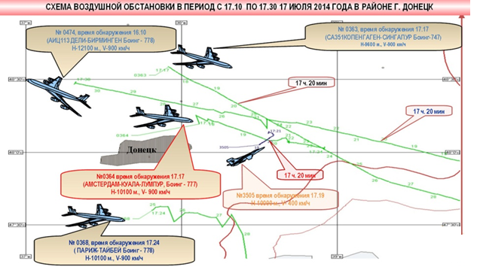

Fig.1 Diagram of the situation in the sky in the area where the Boeing 777 was destroyed (according to data from the Russian Federation Ministry of Defense)

4.2. Meteorological conditions in the area where the Boeing 777 was operating:

Weather records in Torez Donetsk region on Thursday, July 17, 2014
Time | Weather Conditions | Air Temp. | Wind Speed (m/s) | Атм.  дав. | Humidity %
15:00 | Overcast | +31°C | 4.0 | 730 | 29
15:00 | Overcast | +31°C | 4.0 | 730 | 29

4.3. Initial data from the cash site of the Boeing 777

A detailed analysis of its fragments can provide a more complete picture of the causes of the crash. In reviewing the photos of the plane fragments presented on the Internet, you can see the different forms of damage to its shell or skin – tears and factures, holes with folds on the outer and the inner sides of the fuselage, tell-tale signs of a powerful external impact on the plane.

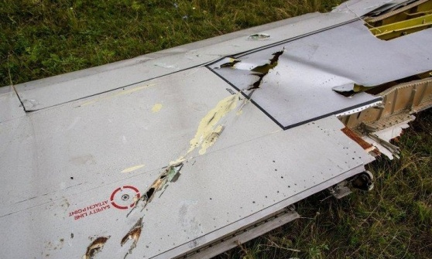  Picture 1. Fragment of the Boeing 777 plane  Фото 1. Фрагмент плоскости Boeing 777 | 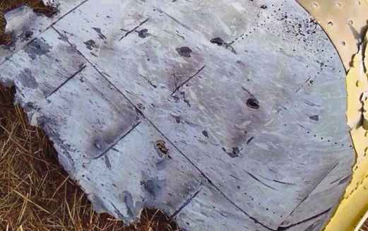  Photo 2. Fragment of the Boeing 777’s shell  Фото 2. Фрагмент обшивки Boeing 777

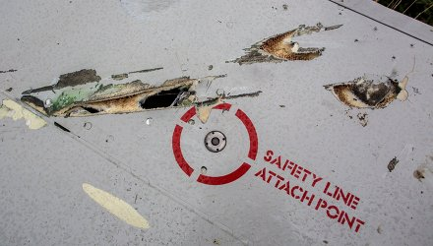  Photo 3. Fragment of the Boeing 777 plane  Фото 3. Фрагмент плоскости Boeing 777 | 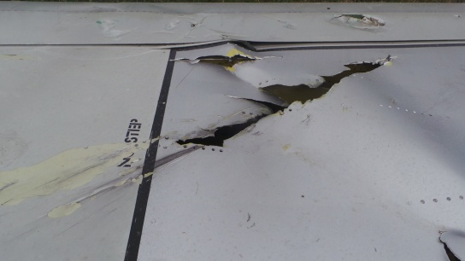  Picture 4. Detail of the Boeing 777 plane  Фото 4. Фрагмент плоскости Boeing 777

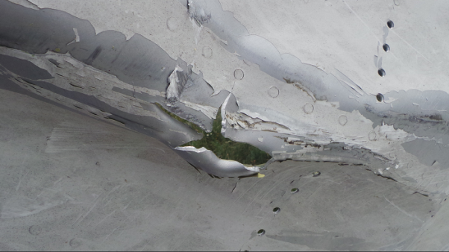  Picture 5. Detail of the Boeing 777’s fuselage  Фото 5. Фрагмент фюзеляжа Boeing 777 | 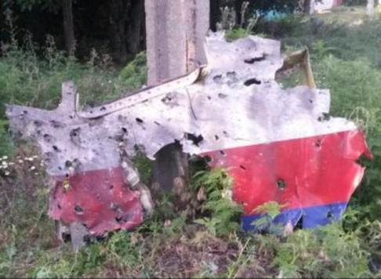  Photo 6. Detail of the Boeing 777 cockpit  Фото 6. Фрагмент кабины Boeing 777

Of particular note are the holes folded inward in the fuselage. They are round-bored, and usually grouped. Such holes can only be formed by metal objects with a circular cross-section, possibly rods or shells from an aircraft gun. The question arises: who could deliver such projectiles to the aircraft, by what means, and what might they look like?

4.4. Characteristics of the Boeing 777 as an airborne target

The fundamental data for analyzing this situation are: the technical data of the Boeing 777; the route it was following; its altitude and airspeed; any change in course from that originally specified; the place where it crashed; photos and videos of the remains of the plane; a description of the radius (debris field) and the nature of the scattered debris.

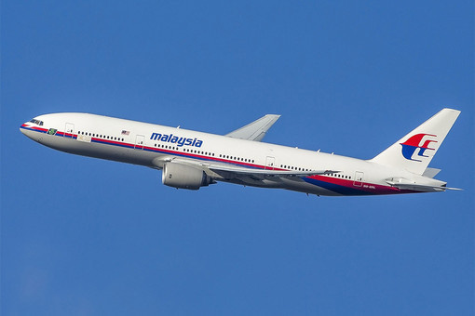  Photo 7. Boeing 777  Фото 7. Boeing 777
  The most important parameters of the Boeing 777
  for purposes of this analysis
  Wingspan, m | 60.93
  Length, m | 63.73
  Height, m | 18.52
  Wing area, м² | 427.80
  Maximum speed, km / h | 965
  Cruising speed, km / h | 905
  Range, km | 8910
  Ceiling, m | 13100

An aircraft like a Boeing 777 is not a difficult target for air defense assets. It is a high-altitude target (at 4,000-12,000 m), has a very large image intensifier (effective reflecting surface) – at least 10 meters (on aircraft such as the Su-25, the II is just 0.5-0.6 m). It has limited maneuverability and no means of anti-aircraft defense (active or passive jamming). They can be hit using combat aircraft (fighter-interceptors or other types of aircraft that operate in the same range of altitudes and speeds), as well as using missile complexes (such as C-200s, C-300s) or military anti-aircraft missiles (such as "Buk-M1").

5. The technical side of the issue

Modern air defense encompasses three categories of means for disabling aerial targets, classified according to the following types:

Type A. - cessation of powered flight;
Type B. - limited continued controlled flight without the ability to land;
Type C. - continued controlled flight with the possibility of landing if necessary repairs can be made.

In this case, according to available evidence, there is reason to believe that the attack was of type (A) - termination of powered flight.
We have studied those basic versions which have already been presented by experts from various countries. Taking into consideration the technical side of the issue, we can assert that the Boeing 777 was destroyed by means of anti-aircraft weapons - either by ground-launched anti-aircraft missiles or by other aircraft armed with missiles and cannon.
Using the methods of engineering analysis, the experts of the Russian Union of Engineers have looked at both of these versions, which practically all the pronouncements of experts and specialists converge toward.

6. The first version. The Boeing 777 was destroyed by an anti-aircraft missile system, for example, a "Buk-M1"

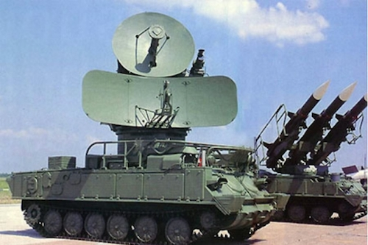  Photo 8. SAM 9K37M1 "Buk-M1"  Фото 8. ЗРК 9К37М1 «Бук-М1»
  TTX 9K37M1 SAM "Buk-M1"
  Start of series production in | 1983
  The affected area in range, km
  - The type of aircraft the F-15 | 3..32—35
  The affected area height, km
  The type of aircraft the F-15 | 0,015..22
  Number of simultaneously engaged targets | 18
  Chance of defeats the purpose of a SAM
  - fighter | 0,8..0,95
  - helicopter | 0,3..0,6
  - A cruise missile | 0,4..0,6
  The maximum speed of the targeted objectives, m / s | 800

6.1. Circumstances militating in favor of the first version
6.1.1. The odds of destroying aerial targets such as the Boeing 777 using the SAM 9K37M1 "Buk-M1" are high, as the aircraft was moving at a level of 10100 meters, at a speed of 900 km / h and its parameters would make it a suitable aerial target for the "Buk-M1." The probability of success for such an attack by a SAM "Buk-M1" is 0.8-0.95; therefore, technically, a hitting such an aerial target is possible.

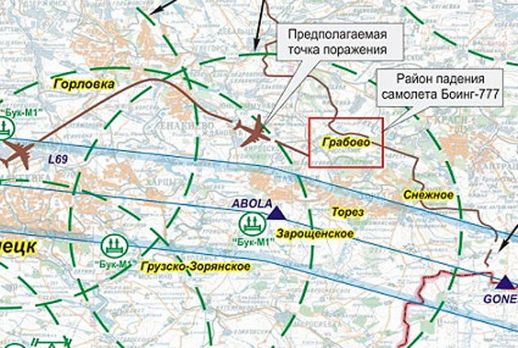  Fig.2. Grouping Ukrainian SAM  Рис.2. Группировка украинских ЗРК | Grouping of Ukrainian troops on July 17 in the crash site numbered 3-4 Position "Buk-M1." This was stated by the Russian Ministry of Defense. The Chief of the Main Operations Directorate of the General Staff, Lieutenant-General Andrew Kartopolov, stressed that the Russian side has pictures from aerial locations of the individual units of the Ukrainian army in the south-east of Ukraine, in particular, "Bukov," 8 km from Lugansk. And on the morning of the day a Malaysian aircraft came down, Russian monitors found a battery SAM "Buk-M1" near the village of Zaroschenskoe. That day it was moved to Donetsk - in the area where the militia are located. We believe these data are objective and accurate.

6.1.2. The SOTS 9C18 Dome Complex (СОЦ 9С18) is capable of detecting and recognising flying targets at a range of up to 100-160 km. Furthermore the complex is capable of detecting low-flying targets (up to 30 metres altitude) at a range of up to 45 km. Such a Radio Location Station (RLC) can be utilised to both detect and track a Boeing 777.
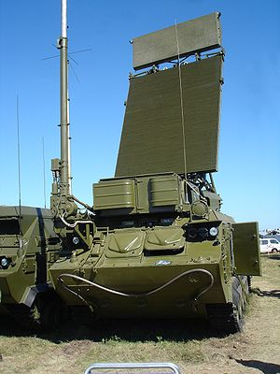  Photo 9. RLC 9С18М1 “Dome”  Фото 9. РЛС 9С18М1 «Купол»
  RLC 9С18М1 “Dome”
  Specification:
  Azimuth, (Degrees). | 360
  Effective Angle, (Degrees).. | 0-40
  Effective Range, km | 10-160
  Разрешающая способность:
  по дальности, м | 400
  по азимуту, град. | 3-4,5
  по углу места, град. | 3-4,5
  Maximum uninterrupted exploitation before maintenance, (Hours) | 48
  Deployment, (minutes). | 5
  Top Speed (knh) | 65

6.1.3. In addition our experts at the Russian Union of Engineers consider that it is important to remark that the launch of a BUK M1 missile is accompanied by the following significant audio- visual effects:
- There is a great deal of noise; both at launch and during the missile flight (esp. between altitudes 100 to 3000m.)
- There is a powerful explosion at the launch site (Photograph 10).
- There is a trail of exhaust, created by the missile, as a result of the burning of fuel during its flight (Photograph 11).
- There is an explosion with a known signature in the air locality at the point of impact between the rocket and its target (Photograph 12).

6.1.4. The narrative detailing the use of the BUK-M1 Rocket complex, in the opinion of our experts, contains a number of issues which render it, as an accurate chronicle of events, open to doubt.
а) No-one, up until now, has been able to produce credible evidence of the launch of a surface to air missile, the launch of which, as is well known, is accompanied by significant audio-visual effects.  The launch trails extend to the clouds and will remain in the air for up to 10 minutes. The sound of the rocket launch is audible to anyone standing within a radius of 7—10 Km from the launch-site. | 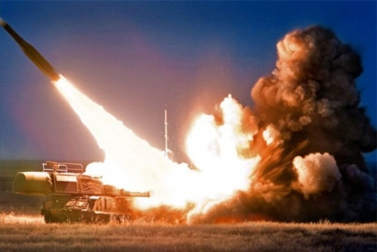  Photo 10. BUK M1 missile launch  Фото 10. Старт зенитной ракеты ЗРК «Бук М-1»

b) The flight of the missile is accompanied by a loud noise. The flight is easily observed thanks to the trail which is produced as a result of the fuel being consumed by the rocket.  In this case there has been no evidence of a trail of white condensation which would be by-product of the consumption of rocket fuel which would appear and persist for some minutes after the launch and be visible to those standing in a radius of within 10 km from the missile launch-site. | 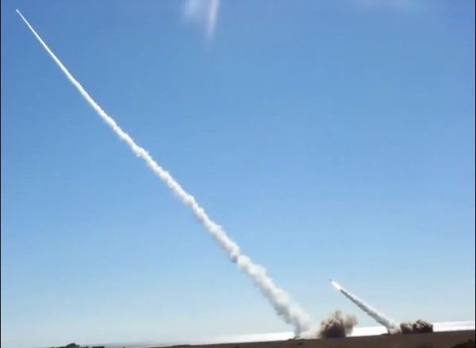  Photo 11. BUK M1 missile in-flight  Фото 11. Ракеты ЗРК «Бук-М1» в полете

c) The impact of the warhead follows a characteristic pattern which can be observed from the ground during clear weather. | 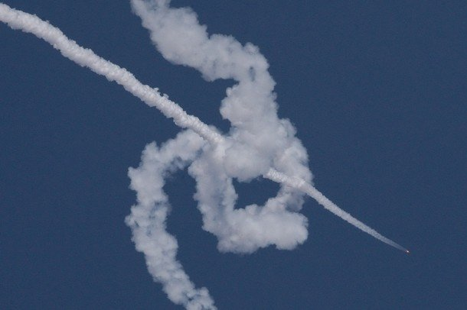  Photograph 12. BUK M1 strikes a target  Фото 12. Поражение воздушной цели ракетой ЗРК «Бук-М1»

The 9M38 missile comes fitted with a two stage solid-fuel engine (expected burn duration approximately 15 seconds)
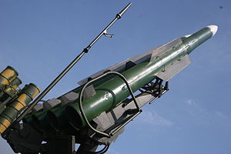  Photo 13. Anti-Aircraft Missile 9М38 BUK M1  Фото 13. Ракеты 9М38 ЗРК «Бук-М1»
  Anti Aircraft Guided Missile 9М38
  Rocket length | 5,5 m
  Diameter | 400 mm
  Fin span | 860 mm
  Rocket weight | 685 kg
  Warhead weight | 70 kg

A surface to air missile, with a warhead weighing between 40 and 50 kilograms does not explode inside the target, rather it explodes in its proximity at a distance of between 50 to 100 metres. The detonation of the warhead’s charge produces a shock-wave, which will sustain the propulsion of shrapnel at high speed. This shrapnel is capable of penetrating the fuselage of a plane. However, when we consider the dimensions of a Boeing 777 (Length 63.7 metres, with a wide wingspan of > 60 metres), shrapnel is incapable of inflicting such damage on the plane that would result in the break-up of a plane of which was six to seven times smaller. Such fragments upon impact with a Boeing 777 could cause damage to the fuel system, resulting in the fuel being released towards the fuselage and the immolation of the aeroplane.

d) In the same way, had the hydraulic system had been damaged, then control upon the Boeing 777 would have been lost or at least control would have been severely impeded (as per scenario ‘c’). In that case, should such a large plane, as the Malaysian Airways Boeing-777, have been hit by a surface to air missile, the flight-crew would have been able to inform air-traffic control of the situation on the plane, however there has been nothing of that sort, certainly from the mass media, disclosed from the decoded on-board system logs.

e) The airliner was shot down in daylight, in a highly populated area, in the presence not only of military participants following the situation in the skies, but also journalists who were armed with cameras, as well as those people who inhabited the area who were correspondingly equipped with telephones and cameras.

Here, it should also be remarked, that, not one person, but at least a military squad would be present at the launch of a BUK M1 missile and that this would make its concealment impossible.

It would correspondingly follow to say that those photographs and video-recordings, taken in real time from different perspectives, showing the different stages of the missile’s flight, would have appeared on the internet in, pretty much real-time (e.g. the media sensation surrounding the asteroid which hit Chelyabinsk). The inhabitants confirmed only that there were explosions and that human bodies fell from the sky amongst their houses.

f) At the time when the Boeing 777 was shot down, there was an American satellite on station. In connection with this, the Russian military are of the opinion that their American partners should bring to wider attention, the satellite images, which were made during the aeroplane’s destruction, should such images be in Washington’s possession.

Conclusion from the first version:

That which has been written above renders doubtful the initial proposition that the Boeing 777 was brought down by the means of anti-aircraft missile fire from a BUK-M1 installation.

7. 2nd version Boeing 777 was destroyed as a result of air-air rocket-cannon fire

7.1. In support of this version the following circumstantial factors can be observed:

7.1.1. There were many witnesses who reported in the sky, in the region where the Boeing crashed, a military plane (some witnesses report two), assumed to be a fighter, as reported, given the height and speed (Altitude of the fighter being 5000—7000 m, and the velocity 950 kmh). There were also reports of aviation noise in the sky. It is possible that these reports relate to MIG-29 or SU-29 aircraft.

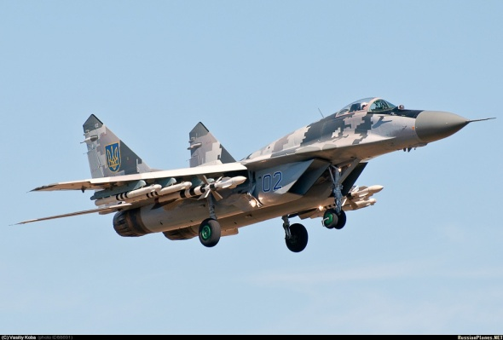  Photo 14. MIG-29  Фото 14. МиГ-29
  MIG-29
  Maximum speed  Максимальная скорость полета – большая высота\у земли | 2450 km/h (М=2,3)\1300 km/h
  Rate of climb  Максимальная скороподъемность у земли, м/с | 330
  Pursuit – from 600 to 1100 kmh from 1100 to 1300 kmh,  Время разгона – от 600 до 1100 км/ч\от 1100 до 1300 км/ч, с | 13,5\8,7
  Takeoff velocity, kmh | 220
  Operational Ceiling (m) | 18000
  Operational Range (With 0/1/3 external fuel tanks), km | 1500\2100\2900
  Maximum turning speed (degrees per second) | 23,5
  Maximum design g-load | +9

The armament of the MIG-29 includes the single-barrelled cannon GSH-301 (30 mm, comprising 150 rounds, rate of fire 1500 rounds/minute) in the port wing root. There are six hard-points under the wing which can be utilised: for Air-Air combat: 6 R60 guided missiles or Р-73 short range I/R guided missiles; 4 close range guided missiles and two mid-range guided missiles Р-27РE with radio lock-on or Р-27ТE I/R guided system Р-77.

Also according to the Russian Defence Ministry, on the 17th of July, Russian Air traffic control tracked an aeroplane, potentially an SU-25, of the Ukrainian Air force, climbing towards the Malaysian Airlines Boeing 777. The distance between the two aircraft did not exceed 3—4 km.

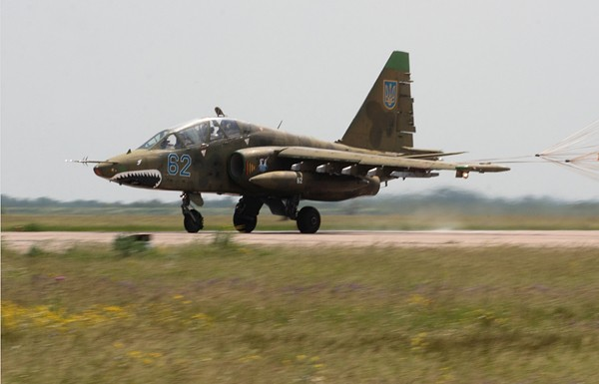  Photo 15. SU-25  Фото 15. Су-25  Armament: 1 × GSh-30-2 30mm cannon mounted below the nose of the plane with 250 rounds  Guided Missiles: Kh-23 (AS-7), AS-9, Kh-25L (AS-10), Kh-29 (AS-14) air-to-surface missiles, K-13 (AA-2) or R-60 (AA-8) air-to-air missiles  SPPU-22 Containers with double-barrelled 23-mm GSH-23L Cannon with 260 rounds
  Su-25
  Wingspan, m | 14.36
  Mass, kg
  Maximum take-off weight (kg) | 17600
  Maximum Speed (kmh)
  At sea level | 975
  At height | М=0.82
  Operational range, (km) | 1850
  Operational Radius (km)
  At height | 1250
  At Sea Level | 750
  Operational Ceiling, m потолок, м | 7000—10000

It must be noted that, in line with its specifications, the SU-25 is capable of briefly reaching heights in excess of 10 thousand metres. Standard equipment includes R60 Air to Air missiles. These missiles are capable of engaging and destroying targets to a range of up to 10km with a 100% hit ratio up to 8 km. Accordingly it is not necessary for the aeroplane to closely approach the target – It will be sufficient to simply ensure that the distance to the target falls within the guaranteed limits of the missile.
7.1.2. The Russian Defense Ministry said that Russian military radar detected the "Dome" Ukrainian air defense system battery "Buk-M1",working, on the day of the Malaysian Boeing 777 disaster.

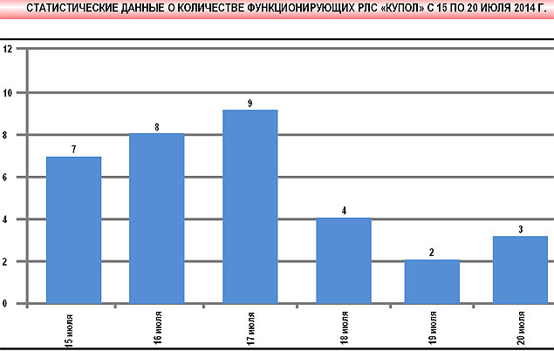  Рис.3. Статистика активности украинских РЛС  в районе гибели малайзийского Boeing 777 | The activity of Radar Location Stations (RLS) can testify to the active deployment of military aviation insofar as the RLS is actively used for air reconnaissance and the transmission of information to the aviation control centre. It is common to provide data to assist the navigator in the coordination of single or groups of fighters to fulfil missions. Such missions include Air Superiority or ambush operations. In these missions an attack can take place either head on or in pursuit with co-ordination from the ground.

7.1.3. An SU-25 and MIG-29 appear identical on radar, insofar as they have similar sized reflective surfaces. The practical surface ceiling of a MIG-29 is 18013 m, thus the height at which the Malaysian airliner was travelling (10100 m) can be easily reached. The MIG-29 has two engines generating high thrust which allows the plane to reach speeds of up to 2000kmh.

7.1.4. The meteorological conditions also support the narrative of the Boeing 777 being attacked by another aircraft. The weather conditions in the region of Donetsk city from 1500 – 1800 on the 17th July 2014 are characterised by rain and thick cloud. The route of the flight passes above the cloud base of the upper level. At this height only cirrus clouds are present. These are sparsely occurring, white fibrous and transparent clouds, occasionally with thick or flaky formations. These are arranged in the apparent bundles or strands stretching across, meeting at the horizon. The average height of the lower boundary of these clouds is between 7 to 10 thousand metres and the cloud layer can measure in width from hundreds of metres to a few kilometres.
An attack by a military plane swiftly ascending from the cloud layer could come as a surprise to the crew of the Boeing 777. The attack would not be observable from the ground because of the thick layer of cloud at the medium and lower levels.

On this basis, the thesis can be advanced with confidence that the Boeing 777 flying a horizontal course at 10000 metres could quite feasibly find itself within range of the Rocket / Cannon armament of a fighter, either a MIG-29 or an SU-25.

7.1.5. The logical Question is: What weapons led to the destruction of the Boeing 777 Malaysian airlines?

Missiles
Both the MIG-29 and the SU-25 can be equipped with short range P-60M guided missiles.

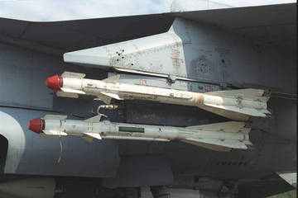  Photo 16. An R-60M Missile externally loaded on the aircraft Фото 16. Ракеты Р-60М на внешней подвеске самолета
  Р-60М
  Length, m | 2,14
  Diameter, m | 0,12
  Wingspan, m | 0,39
  Mass, kg | 45
  Warhead mass, kg | 3,5
  Speed | 2,5М
  Altitude range of target to be destroyed | 0,03...20
  Maximum engagement range, ППС/ЗПС | 10/8 км
  Minimum firing range, ЗПС, км | 0,3 - 0,25

The MiG-29 is equipped with a 30-millimeter GSh-301 cannon, firing at a rate of 1500 rounds per minute. This gun is loaded with 150 shells containing tungsten alloy. Its effective range for airborne targets is 200-800 m, for land-based targets, 1200-1800 m. This kind of projectiles pass through, leaving a track that is perfectly round in shape; they do not explode inside the cabin and are not incendiary, but they can kill the crew and destroy the cabin. The entry and exit holes exhibit a typical configuration. The entry holes show the edges pushed inside the opening; on the opposite wall, the edges are pushed outward.

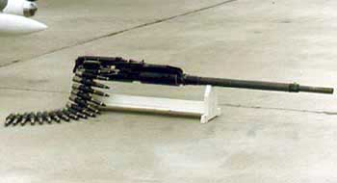

Photo 17. G-Sh310 Aircraft gun
Фото 17. Авиационная пушка ГШ-301
The Su-25 is equipped with GSH-2-30 guns.

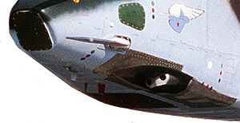  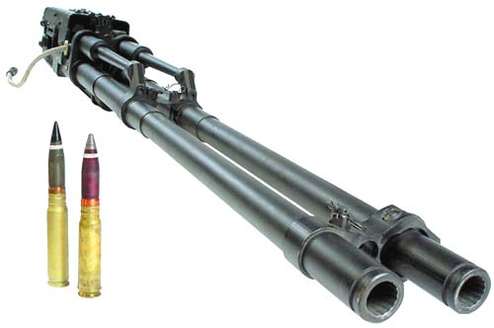  Photo 18. Aircraft Cannon GSh-2-30  Фото 18. Авиационная пушка ГШ-2-30
  GSH-2-30 (GSH-2-30K)
  Carriers | Су-25, Су-39, (Ми-24П)
  Weight
  shell weight | 390 g
  Cartridge weight | 832 g
  Cannon weight | 105 (126) kg
  Features
  Calibre | 30 мм
  Number of trunks | 2
  Ammunition | 250 (750) Cartidges
  Rate of Fire | (300— 2600)  выст/мин
  Effective range against air target | 200—800 м.

In addition the Su-25 may carry SPPU-22 containers with 23-mm GSh-23L dual-barrel cannons.
During combat both types of cannons are used against aerial targets to cause damage analogous to that seen on the wreckage of the Boeing 777.

Conclusion on the second version:

Thus, according to the analysts from the Russian Union of Engineers, we have the complete destruction of the Boeing 777 as [a result of] missile systems using "air-to-air" close-combat missiles as well as a 30-mm aircraft cannon or an SPPU-22 container with GSh-23L 23-mm dual-barrel guns. At the same time, when firing on a target, a laser range finder can be used, or a laser sight, that allows for significantly improved accuracy. This is indicated by the pattern of damage and the dispersal of the fragments: there are round holes, which are typically produced as a result of gun shots, and discontinuous holes characteristic of flechette rockets.

8. Analysis of the debris

If we consider the first version of the crash, it is evident from the way the holes are arranged in the fragments of the flat surfaces and the fuselage that they do not reflect the typical picture of the impact of "Buk-M1" missiles, which would have left a very noticeable and characteristic pattern of damage marks. In this case, it is clear that there are no such traces on the debris fragments.

As far as the possibility of such damage resulting from close-combat "air-to-air" missiles, it should be noted that the R-60 (Su-27) and R-73 (Mig-29) are low-power rockets for close air combat, with infrared guidance. Their kill radius is only 3-5 meters, and a sure hit requires direct contact. The mass of the warheads in the former case is 3.5 kg, in the latter, 5 kg. The warheads contain fine particles of tungsten wire. These are pretty weak rockets; they are designed exclusively for small targets. Such missiles follow the heat trail and are primarily designed to kill the engine.

It would be logical to assume that the damage shown in photo 19 is more commonly associated with aircraft cannon shells of the GSH or SPPU type.

Damage to the Boeing 777 is not characteristic of the SAM “BUK-M1” missile  Повреждения плоскости  «Boeing 777» не характерны для поражающих элементов ЗУР ЗРК «Бук-М1» | 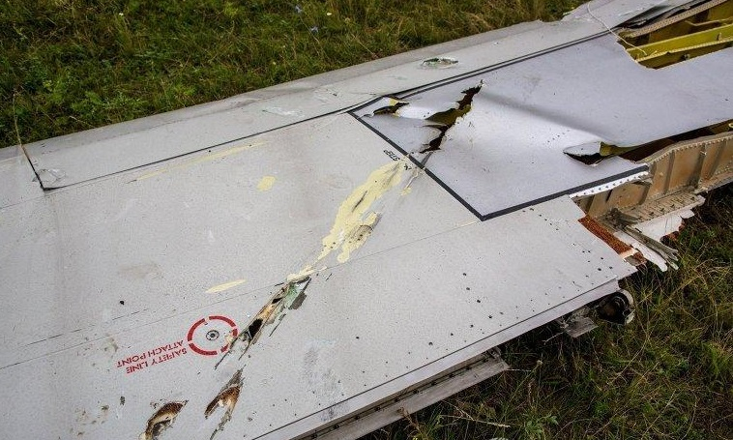  Photo 19. Damage to the flat surfaces of the Boeing 777  Фото 19. Повреждения плоскости Boeing 777

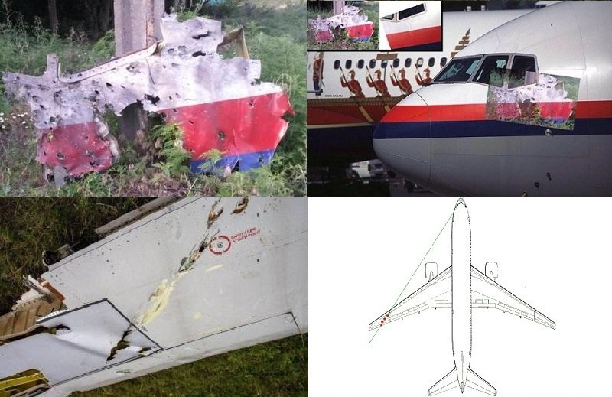

Photo 20. The nature of the damage to the cabin of the Boeing 777
Фото 20. Характер повреждений кабины Boeing 777

The picture of the entry and exit holes in the cockpit of the Boeing 777 are fully consistent with the passage through the flight of shells from the 20-30 mm caliber guns found on military aircraft. This confirms the second version of what brought down the Boeing. This is further supported by the way the puncture holes are dispersed along the surface of the aircraft. The edges of the fragment of the fuselage from the left side of the cockpit are folded from the inside outward, which indicates that a significant blast occurred within the cockpit as a result of the dynamic impact of the shells on the right side.
On the trim panel the characteristic entry holes are visible as well as some exit points. The edges of the holes are bent inward; they are much smaller and are circular in shape. The exit openings are less clearly formed; their edges are torn outward. In addition, it is clear that exit holes broke through double aluminum lining and tilted it outward. That is, the strike elements ([judging] by type of impact - aircraft cannon shells) punched right through the cockpit. The open rivets were also bent outward.

A fragment of the Boeing 777. Clearly seen are the entry holes in the outer layer, folded inward, caused by a
30-мм gun.

The inward folds are clearly seen, which are characteristic of this type of projectile.
Projectile Shell
GSh-2-30
Снаряд пушки
ГШ 2-30

Photo 21. nature of the damage skin Boeing 777
Фото 21. Характер повреждений обшивки Boeing 777

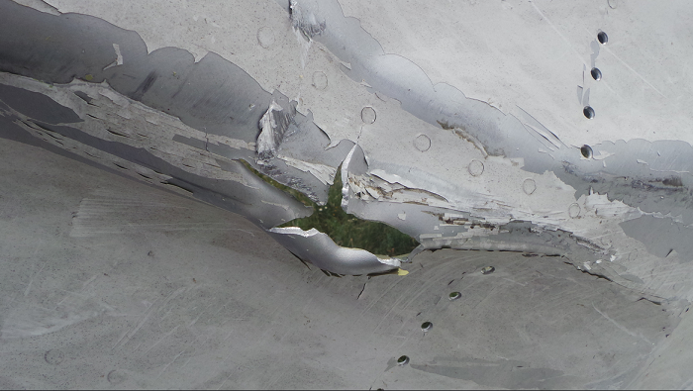  Photo 22. nature of the damage skin Boeing 777  Фото 22. Характер повреждений обшивки Boeing 777 | Fragment of Boeing 777.  Taken off the rivet.  Rupture of the fuselage from the inside to the outside edges of the impact blow that is caused by any explosion inside the airplane, or a sharp drop in internal pressure at high altitude

The general typology of the holes and their location suggest that is most likely the Boeing 777 was fired on using a GSh-2-30 aircraft cannon or an SPPU-22 container with dual-barrel 23-mm GSh-23L cannons: sighting was targeted in the area of the cockpit; while the shells that broke through the cockpit proceeded out the other side and caused damage to the flat surface of the wing (see photo 20). Both types of weaponry cause damage to aerial targets analogous to that seen on the fragments of the Boeing 777.

The nature of the holes on the fragments of the skin surfaces and fuselage shown on information networks allows us to assert that it was missiles/gunfire from an aircraft that was used.

9. Reconstucting the event

Based on the above, we can draw the following conclusions:

9.1. In relation to the circumstances of the crash of the Malaysia Airlines Boeing 777 jet.

The Malaysia Airlines Boeing 777 was carrying out the 17.07.2014 flight Amsterdam - Kuala Lumpur in the flight corridor established by the dispatchers. At the same time, it is likely that manual control was turned off and the plane was on autopilot, flying in a horizontal plane along the route laid out and adjusted by air traffic controllers on the Ukrainian side.
At 17.17-17.20, the Boeing 777 was in Ukrainian airspace near the city of Donetsk at the height of 10100 m. An unidentified combat aircraft (presumably a Su-25 or MiG -29), which was a tier below, on a collision course, in the cloud layer, sharply gained altitude and suddenly appeared out of the clouds in front of the civilian aircraft and opened fire on the cockpit, firing from a 30 mm caliber cannon or smaller. The pilot of a fighter jet can do this while in "free hunting" mode (using onboard radar) or with the help of navigational guidance using airspace situation data from ground-based radar.
As a result of multiple hits from shells there was damage to the cockpit, which suddenly depressurized, resulting in instant death for the crew due to mechanical influences and decompression. The attack was sudden and lasted a fraction of a second; in such circumstances the crew could not sound any alarm as the flight had been proceeding in regular mode and no attack was expected.

Since neither the engines or hydraulic system, nor other devices required for the continuation of the flight were out of commission, the Boeing 777, running on autopilot (as is standard), continued on its horizontal flight path, perhaps gradually losing altitude.

The pilot of the unidentified combat aircraft maneuvered to the rear of the Boeing 777. After that, the unidentified plane remained on the combat course, the pilot provided a target tracking aircraft equipment, took aim and launched his R-60 or R-73 missiles.

The result was a loss of cabin pressure, the aircraft control system was destroyed, the autopilot failed, the aircraft lost the ability to maintain its level flight path, and went into a tailspin. The resulting overload led to mechanical failure of the airframe at high altitudes.

The aircraft, according to the information available from the flight recorders, broke up in the air, but this is possible only in the case of a vertical fall from a height of ten thousand meters, which can only happen when the maximum permissible overload is exceeded. One reason for stalling and going into a tailspin is the inability of the crew to control the aircraft as a result an emergency in the cockpit and the subsequent instantaneous depressurization of the cockpit and the passenger cabin. The aircraft broke up at a high altitude, which explains the fact that the wreckage was scattered over the territory of more than 15 square kilometers.

9.2. In relation to the party responsible for the death of 283 passengers and 15 crew members.
On 17.07.2014, the armed forces of the self-proclaimed Donetsk National Republic had no relevant combat aircraft capable of destroying an aerial target similar to the Boeing 777, nor the necessary airfield network, nor the means of radar detection, targeting and tracking.

No combat aircraft of the Armed Forces of the Russian Federation violated the airspace of Ukraine, which the Ukrainian side confirms as well as third parties who conduct space surveillance over the situation in Ukraine and in its airspace.

To establish the truth, it is necessary to objectively and impartially investigate all the circumstances of the destruction of the Malaysian Boeing 777, to interview the thousands of citizens who may have seen something. Naturally, experienced professionals should conduct the surveys. To ask the right questions - this is a rigorous science, and a great art in advancing the truth. Important information is contained in the wreckage of the aircraft and the remains of the dead, but this precise information is easy to destroy, distort and hide. And there are plenty of parties interested in concealing the real facts. As confirmation, Ukraine, the Netherlands, Belgium and Australia signed an agreement on August 8 providing that information about the crash investigation would be disclosed only upon the consent of all parties. "The investigation is ongoing, [utilizing] expertise and other investigative actions” – announced the Spokesman of the Prosecutor General of Ukraine, Yuri Boychenko. “The results will be announced at the conclusion of the investigation and with the consent of all parties that have executed the agreement."

Procrastination and the evasion of an objective investigation by all sides, with the participation of prestigious international organizations, raises doubts whether the concerned parties will make public the true circumstances surrounding the crash of the Malaysia Airlines Boeing 777.

First Vice-President of the All-Russian Public Organization
"Russian Union of Engineers”
Chairman of the Board of Directors of the Engineering Company "2K"
Ivan A. Andrievskii

Translation by: Alice & Gideon (Russian Saker / Oceania Saker)
Editing & Production: Augmented Ether (Oceania Saker)
Geopolitical Analysis:
http://vineyardsaker.blogspot.com (English)
Opinion pieces from around the world:
http://www.vineyardsaker.co.nz (English – Oceania)
http://www.vineyardsaker.fr (French/français)
http://www.vineyardsaker.ru (Russian/русский)
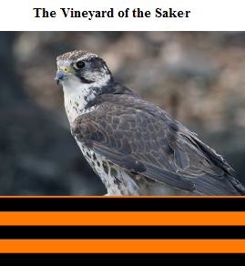http://www.vineyardsaker.de(German/deutsch)

